Date of referral: dato

Referral for Danish language education

Dear navn

Welcome to kommunenavn.

You have come to Denmark in order to work, study or the like. As a result, you are entitled to free Danish language lessons at the Danish language education, provided by your municipality. The lessons will be held at a Language Centre and you will attend language lessons together with others who have recently come to Denmark and are new to the Danish language.

You are hereby referred to a Danish language education run by the following Language Centre: navn.

Som kommune vælg enten denne tekst
If you would like to make use of the offer, you must contact the Language Centre at the following address: adresse og tlf.

Eller denne tekst
If you would like to make use of the offer, you must contact the municipality. The name and contact details at the municipality are as follows: Navn på kontaktperson, adresse, telefonnummer, email.

It is important that you contact us and start your Danish language lessons as soon as possible, as you can otherwise loose important time to complete your Danish Language education.
Important notice
You are entitled to classes for a period of up to five years. Whether or not you wish to attend Danish language education is up to you.

The five year period is calculated from the date of this referral letter. This is still the case whether you react to this referral or not, i.e. the five year period begins whether or not you contact or show up at the Language Centre or the offices of the municipality.

Free choice of Language Centre
You may choose a different Language Centre instead of the one you have been referred to. The municipality can provide you with more information regarding this option.

Deposit
A Danish language education is divided into modules. You must pay a deposit of 2.000 kr. prior to commencing a module. The 2.000 kr. are to be paid to the Language centre and will be reimbursed if you finish the module within a defined deadline. The deadlines are outlined in the table below. This means that you e.g. have 6 months to finish module 1 – if you wish to have your deposit reimbursed. The language centre will provide you with more information regarding the rules for reimbursement.
The education itself is free of charge.

Please note: If you are in Denmark as an au-pair, you do not have to pay the deposit.

Table outlining the deadlines for finishing each module in order to have your deposit reimbursed
Education in Danish language 1, 2 and 3
Modul 1 | 6 months
Modul 2 | 6 months
Modul 3 | 7 months
Modul 4 | 8 months
Modul 5 | 9 months
Modul 6 ( Danish language education 2 and 3) | 9 months

What does the offer of a Danish language education entail?
At the Language centre, you will be placed on one of three Danish Language Courses, depending on your qualifications. A Danish language education is completed by passing an final exam in which both your written and oral skills are tested. You can attend the lessons during the day or in the evening.
As mentioned above, a Danish language education consists of several modules. Each module is completed by passing a test (please see the diagram outlining the three Danish Language educations at the end of this document). If you have not already learnt some Danish, you will typically be placed on module 1. If you are already able to speak some Danish, you will be placed on one of the more advanced modules.
For every module, you are only entitled to receive classes until you pass the test/exam. It is the Language Centre that decides when you are ready to take the final test.

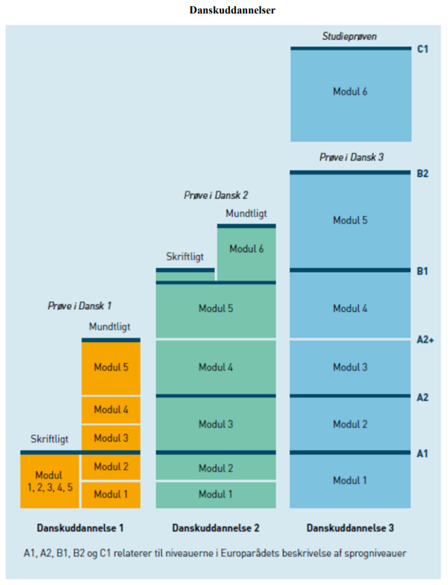
Translation of terms used in the illustration above:
- Danskuddannelser = Danish language educations
- Studieprøven = The Higher Danish Education Exam
- Skriftligt = Written
- Mundtligt = Oral
- Modul = Module
- Prøve i Dansk 1, 2 eller 3 = Danish Exam 1, 2 or 3
- Danskuddannelse = Danish language education
- A1, A2, B1, B2 og C1 relaterer til niveauerne i Europarådets beskrivelse af sprogniveauer = A1, A2, B1, B2 and C1 refer to the levels noted in the European Council’s description of levels of language skills.

